FACULTY -BIODATA
Department | MCA |  |  |  |  |  |  |  |  |  |  | 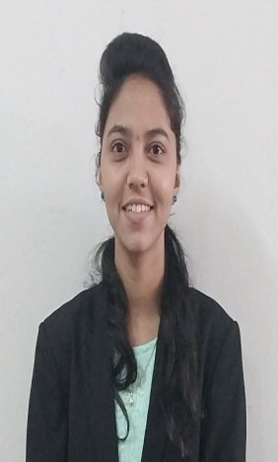
Designation: | Lecturer(Assistant Professor)
Name of Faculty: | Miss. Triveni Vijay Kirdat
Date of Birth: | 07/07/2000 | Date of Joining: |  |  |  | 19/06/2023
Qualification with Class/Grade | UG | PG |  |  |  | Ph.D.
 | 1st Class with Distinction | 1st Class with Distinction |  |  |  | _
Area of Specialization:
Total Experience in Years: | Teaching |  |  | Industry |  |  |  |  |  |  | Research
 | - |  |  | - |  |  |  |  |  |  | -
Mobile No: | 7218085435 |  |  | E-mail ID: |  |  |  |  |  | kirdattriveni@gmail.com
Number of PhD, M.Tech , B.Tech Project Guided | UG: - |  |  |  |  |  | PG: - |  |  |  |  | Ph.D. : -
Professional Society Memberships | -
Paper Published in Journals | National: - |  |  |  |  |  |  | International: -
Paper Presented in Conferences | National: - |  |  |  |  |  |  | International: 0
Books/Chapters/ Patents / Copy rights Published | Books: - | Chapters:- |  |  |  |  |  | Patents: |  |  |  | Copyrights: -
STTPs, FDPs, Workshops attended | STTPs: |  |  |  | FDPs: |  |  |  |  |  | Workshops: 2
Webinars & Seminars attended | Webinars: 1 |  |  |  |  |  |  |  | Seminars: 2
STTP, FDP,Webinar& Seminar conducted | STTP: |  | FDP: |  |  |  |  | Seminar: |  |  |  | Webinar:
Resource Person Work Details
NPTEL/Swayam/NITTR/MOOC/ Other courses | MOOC Course
Awards/Recognitions
Consultancy Activities | O
Google Scholar Link
Google Site/Website link

Name & Signature of Faculty

