FACULTY -BIODATA
Department | Faculty of MCA |  |  |  |  |  |  |  |  |  |  |  | 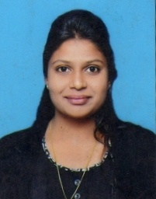
Designation: | Assistant Professor
Name of Faculty: | Pranjali Sadashiv Gade
Date of Birth: | 29/05/1996 |  |  | Date of Joining: |  |  |  |  | 02/10/2021
Qualification with Class/Grade | UG |  |  | PG |  |  |  |  | Ph.D.
 | First Class with Distinction |  |  | First Class with Distinction |  |  |  |  | -
Area of Specialization: | -
Total Experience in Years: | Teaching |  |  |  | Industry |  |  |  |  |  |  | Research
 | 1.8 |  |  |  | - |  |  |  |  |  |  | -
Mobile No: | 7057995337 |  |  |  | E-mail ID: |  |  |  |  |  | psg_mca@yes.edu.in
Number of PhD, M.Tech , B.Tech Project Guided | UG: 0 |  |  |  |  |  | PG:28 |  |  |  |  |  | Ph.D. :0
Professional Society Memberships | 0
Paper Published in Journals | National: 0 |  |  |  |  |  |  | International: 0
Paper Presented in Conferences | National: 0 |  |  |  |  |  |  | International: 0
Books/Chapters/ Patents / Copy rights Published | Books: -0 | Chapters:- 0 |  |  |  |  |  | Patents: 0 |  |  |  |  | Copyrights: -0
STTPs, FDPs, Workshops attended | STTPs: 0 |  |  |  |  | FDPs: 2 |  |  |  |  |  | Workshops:
Webinars & Seminars attended | Webinars: 0 |  |  |  |  |  |  |  |  | Seminars: 0
STTP, FDP,Webinar & Seminar conducted | STTP: 0 |  | FDP:0 |  |  |  |  | Seminar:0 |  |  |  |  | Webinar: 0
Resource Person Work Details | -
NPTEL/Swayam/NITTR/MOOC/ Other courses | -
Awards/Recognitions | -
Consultancy Activities | O -
Google Scholar Link | -
Google Site/Website link | -
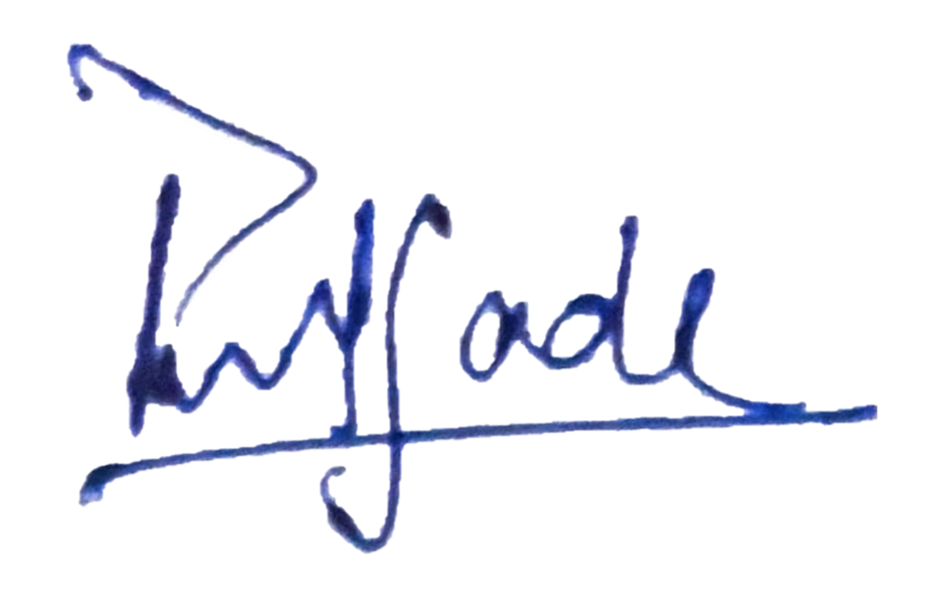

Name & Signature of Faculty

